U5 Revision srijeda 20.05.2020.
(p. 62)

Za početak jedna pjesmica za ponavljanje. The prepositions song
Koje smo sve prijedloge naučili u ovoj lekciji?
under – ispod behind – iza next to – pored in front of – ispred
opposite – nasuprot between – između on – na in – u
Pogledajte sliku, pronađite predmete i popunite rečenice.
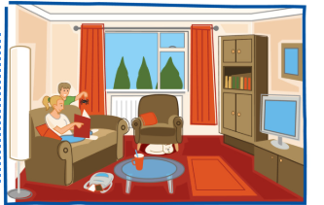
Look at the picture and complete the sentences:
The table is in front of the sofa.
The cat is under the armchair.
The schoolbag is between the sofa and the table.
The lamp is next to the sofa.
Olie is behind the sofa.
The sofa is opposite the TV.
Ollie's sister is on the sofa.

Kada želimo reći da se nešto negdje nalazi koristimo izraze THERE IS ili THERE ARE
No moramo biti pažljivi!
Ako govorimo o samo jednoj stvari reći ćemo There is… ili There isn’t (ako se nešto tu ne nalazi).
Ako govorimo o više stvari reći ćemo There are… ili There aren’t

Pogledajmo sličicu u udžbeniku, gdje se nalaze zgrade u ovom gradu?
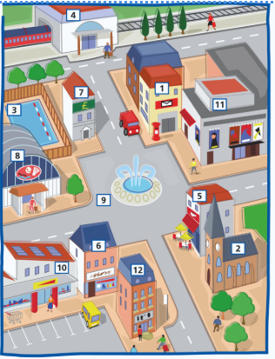

There is a fountain in the square.
There isn't a cinema next to the cafe.
There are tables in front of the cafe.
There aren't two banks in this town.

Na stranici Liveworksheets imate 2 nova listića, pa ih riješite za domaću zadaću.
https://www.liveworksheets.com/

Hope to see you soon!
Ta fotografija korisnika Nepoznat autor: licenca CC BY-NC-ND
Your teacher

